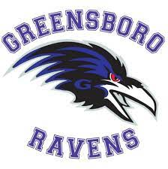

Greensboro Ravens Football Release Form

I, release to
(Greensboro Ravens Rep) (Player Name)

the for the current AYF-PYFCL season. He/She is in good
(Requesting Association)

standing with the Greensboro Ravens Football Organization.

Greensboro Ravens Football Commissioner Date

PYFCL Football Commissioner Date

